DB-Mill-HMI

Introduction

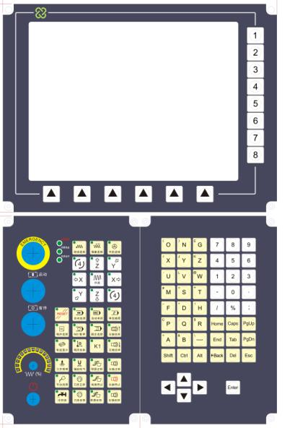
Considering the particularity of china machine application we launched the operation interface and NC keyboard.
These three components can have a variety of combination.For Example:
- Display+Keyboard+NC board
- Display+Keyboard
- Display+NC board
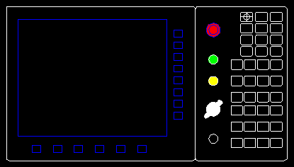
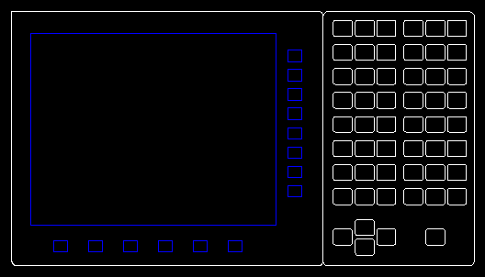
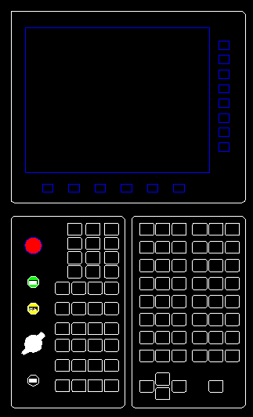

If some industry users didn’t like mouse ,They can choose Display+ Keyboard+NC board.IF the machine has mouse and keyboard,we recommend Display+NC board ,and so on.

Display
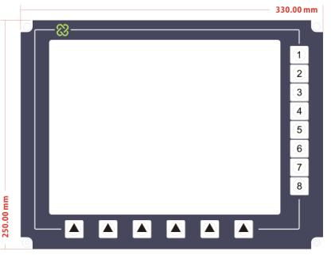
- Resolution: 800X600(Industrial grade display screen)
- Display type VGA
- Power Supply: AC220V，50W
- Size: 330mm*250mm
- Positive protection grade IP64
- 14 keys for PA’S HMI 8 soft key and 6 hard key for PA’S HMI

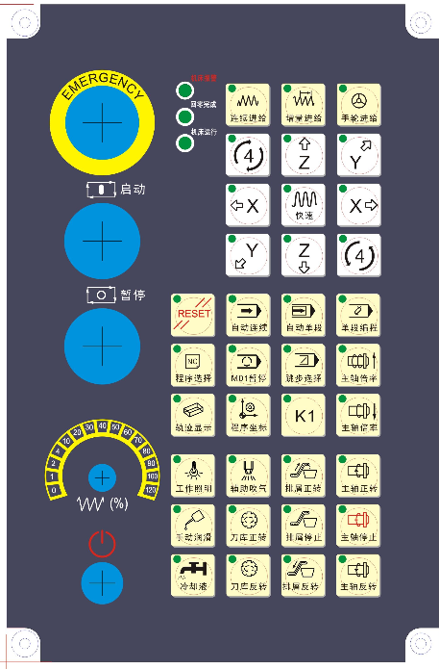
NC board
- Size 165mm*250mm (Display width 1/2)
- RS232 NC board (PA serial port protocol)
- DC24V power supply
- The emergency stop switch for the user
- Separate Start and stop switch in PCB
- Tosoku Override switch in PCB
- Self locking Power switch
- 36 Keys for mill (OMRON)

The PLC address:(Picture rotate 90 degrees)
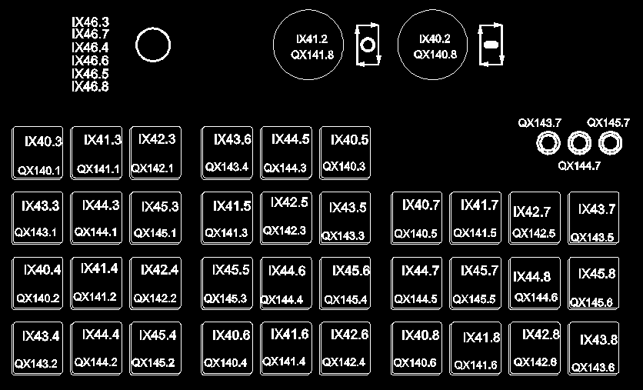

Functions list :
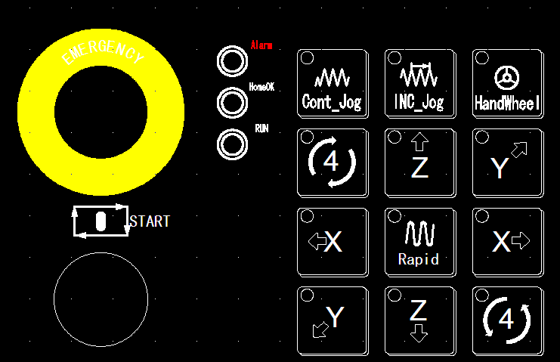
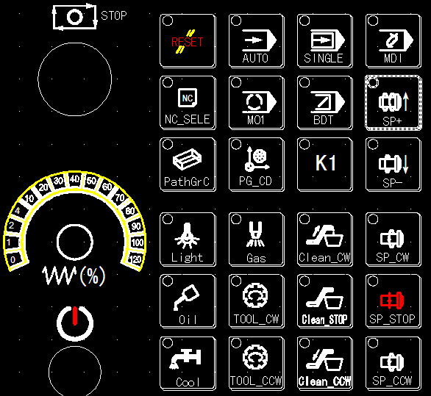

KEY board
- Size 165mm*250mm (Display width 1/2)
- PS2 Interface (PA8000LW/E2 Special interface PS2)
- 53 Keys
- DB9 interface in PCB to Host PS2

